CYBR3030 – Cryptography Case Study Report
Prepared for: Bruce Wayne, CEO, Edmonton Comics
Prepared by: Cybersecurity Consultant
Date: __________

Table of Contents
1. Summary
2. Network Diagram
3. Gap Analysis & Risks
4. Cryptography for Securing Data
5. Secure Data Sharing with Partners
6. Best Algorithms for Data in Transit & at Rest
7. Rationale for Algorithm Selection
8. Certificate Recommendation
9. References

Summary
Edmonton Comics is preparing to release a new comic series and is collaborating with two external partners, Echo Republic and Anime Fuel. Due to the sensitive nature of the work, ensuring strong data protection is critical. This report identifies several security gaps—including plaintext password storage, usage of a self-signed certificate, and unencrypted partner communications—and provides recommendations for modern cryptographic controls. These protections include encrypting data in transit using TLS 1.3, encrypting data at rest using AES-256, implementing secure password hashing with Argon2, and replacing the self-signed certificate with a trusted CA-signed certificate. Additional recommendations include introducing secure API tokens, enhancing authentication mechanisms, and improving network segmentation. These changes will significantly enhance data confidentiality, integrity, and system resilience.

Network Diagram
The diagram below illustrates the current Edmonton Comics network environment:
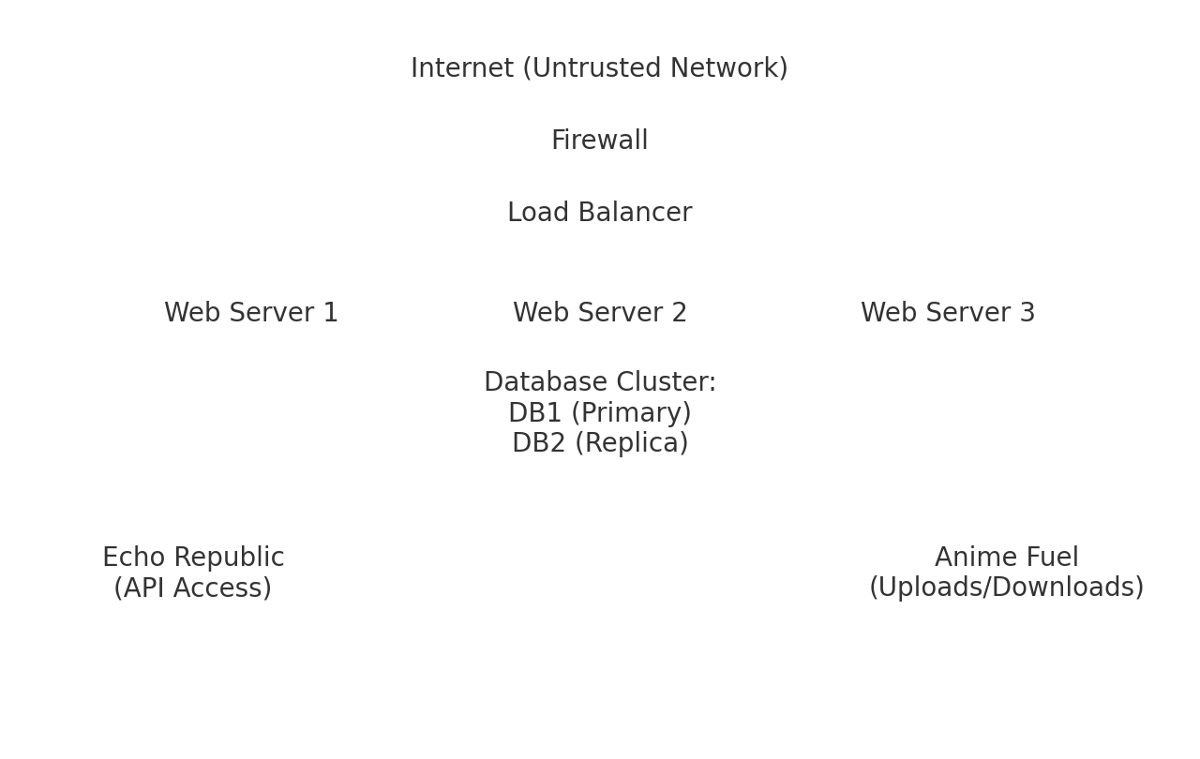

Gap Analysis & Associated Risks
The following gaps and risks were identified in the current environment:
1. **Plaintext usernames and passwords** stored on web servers pose a severe compromise risk.
2. **Use of a self-signed certificate**, allowing attackers to perform man-in-the-middle (MITM) attacks.
3. **Unencrypted partner communications**, exposing sensitive comic content and project data.
4. **Lack of encryption for data at rest**, leaving intellectual property vulnerable if servers are breached.
5. **Weak authentication mechanisms**—no MFA or token-based system in place.
6. **API vulnerabilities**, such as missing signing, encryption, and rate limiting.
7. **Limited network segmentation**, increasing risk of lateral movement.
8. **No defined key management or rotation policies**, reducing cryptographic effectiveness.
9. **Shared credentials between partners**, increasing accountability and traceability risk.
10. **Lack of secure audit logging**, making incident response more difficult.

How Cryptography Keeps Company Data Secure
Cryptography provides protection for confidentiality, integrity, authentication, and non-repudiation. The following cryptographic concepts apply to Edmonton Comics:
**1. Confidentiality** – Encryption ensures that only authorized users can read data. AES-256 encrypts stored content, while TLS 1.3 protects data during transmission.
**2. Integrity** – Hashing and digital signatures ensure that data cannot be modified without detection.
**3. Authentication** – Cryptographic certificates verify the identity of users and servers.
**4. Non-repudiation** – Digital signatures prevent partners from denying their actions.
By applying these cryptographic principles, Edmonton Comics can protect sensitive comic content, internal communications, and intellectual property.

Secure Data Sharing with Authorized Partners
To securely collaborate with Echo Republic and Anime Fuel, the following security controls should be implemented:
• **TLS 1.3 encryption** on all APIs and web portals.
• **Mutual TLS (mTLS)** for partner authentication.
• **API tokens or signed JWTs** for Echo Republic.
• **SFTP or secure upload portals** for Anime Fuel.
• **Role-based access control (RBAC)** to limit permissions.
• **Least-privilege principles**.
• **Audit logging** for all data transfers.
These measures ensure that only authorized users access project data and that all communication remains encrypted.

Best Algorithms for Securing Data (Transit & Rest)
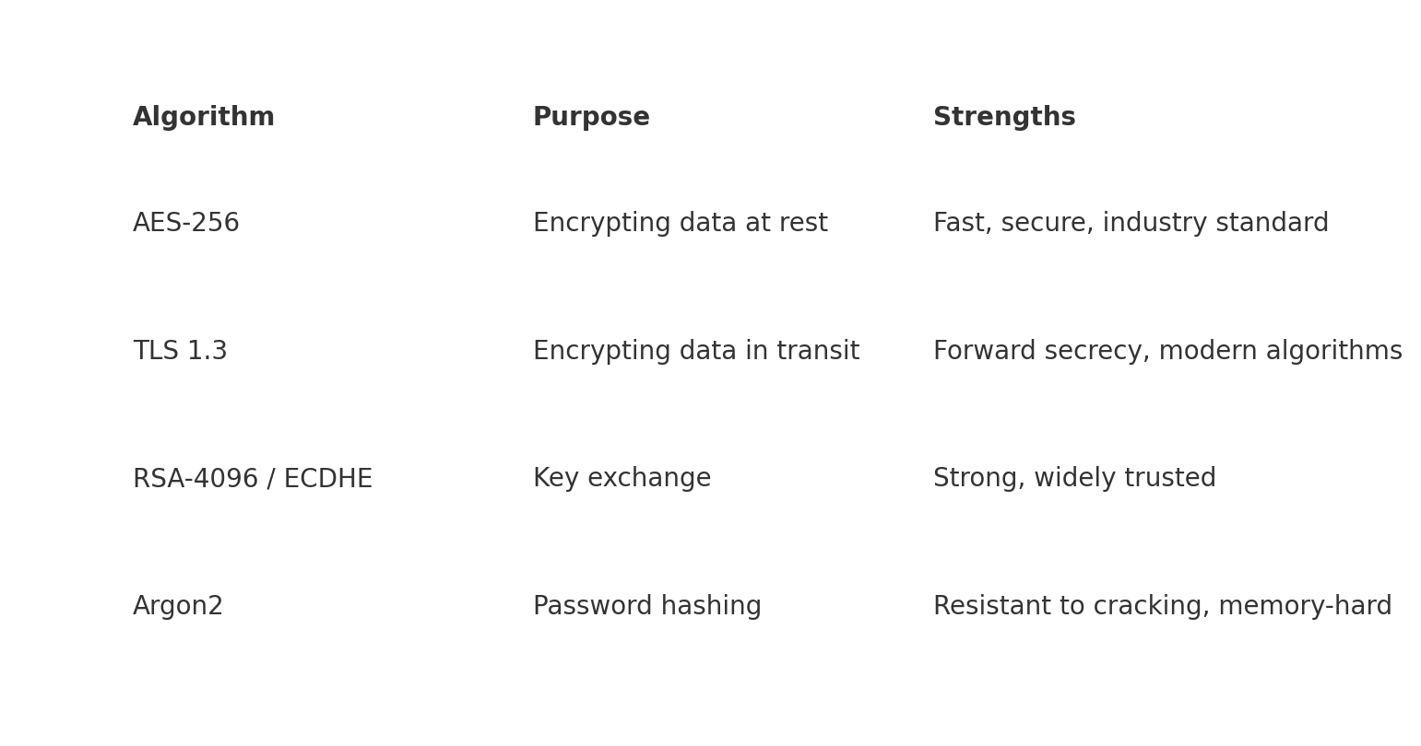
The algorithms shown above represent the strongest cryptographic options currently available. AES-256 provides high-speed, reliable encryption for data at rest. TLS 1.3 is the modern standard for securing communication channels. RSA-4096 or ECDHE ensure secure and authenticated key exchange. Argon2 provides robust password protection.

Rationale for Algorithm Selection
**AES-256** was chosen for data at rest due to its performance, low overhead, and approval by NIST.
**TLS 1.3** was selected for data in transit because it removes outdated weak algorithms and enforces forward secrecy.
**ECDHE** is preferred over RSA for key exchange because it is faster and supports forward secrecy.
**Argon2** was selected due to its memory-hard design, protecting against GPU-based brute-force attacks.
These algorithms are widely supported, security-audited, and recommended by industry bodies such as NIST and OWASP.

Recommendation Regarding Self-Signed Certificates
A self-signed certificate is **not** sufficient for current or future projects. It does not validate server identity and exposes the system to MITM attacks. Instead, Edmonton Comics should adopt:
• **CA-signed TLS certificates** for all external services.
• **Automated certificate management** (e.g., Let's Encrypt, AWS ACM).
• **Regular certificate renewal and rotation**.
This ensures authenticity, trust, and reliable secure communication with external partners.

References
• NIST SP 800-63 Digital Identity Guidelines
• NIST SP 800-57 Key Management
• OWASP Cryptographic Storage Cheat Sheet
• CIS Controls v8 Security Baselines

